Assessment Parameters

- Solution Completeness (all requirements addressed) – 20 %
- Working solution for each requirement – 40 %
- Comments – 20%
- Coding standards – 20 %

Section 1 – Programming Foundation with Pseudocode [10 marks]

Write a pseudo code to print the grade of given employee based on their salary.
Follow the modular approach to implement above logic.

Accept employee id and salary from user. If given employee is not valid then print the appropriate error messages like “Employee Id cannot have Digits”

Level-3 Salary<25000
Level-2 25000<=Salary<50000
Level-1 50000<=Salary

Marks Distribution:

Subroutine Logic | 6
Best practices usage | 2
Exception Handling | 2

Section 2 – HTML and JavaScript [25 Marks]

Design a form to accept the details of the Employees for raising I-Connect tickets. Use CSS (cascading style sheet) to design the web page. Perform the following validations.

Do the following:
- All fields are mandatory (Except check box)
- Employee Id should be of 6 digits and should not start with 0.
- Employee name should not be less than 5 characters and maximum up-to 25 characters
- Priority as a radio button containing values as High, Medium, Low
- Description text area describing the reason for raising tickets.
- Ticket raised date is mandatory
- Mobile number should be of 10 digits starting with [9]
- Create Drop list of Functions for I-Connect tickets to be raised as below:
  - IT Infrastructure Mgmt
  - Admin
  - Travel and Transport
7. Write a JavaScript function to
a. Populating Category drop down list based upon the Functions selected:
Refer below table for same.
- To check if Ticket raised date is system date. If not then raise a java-script error.
- Validate the selection of check box. If check box is selected then a
message should be raised as “Multiple users / Systems Impacted” else no message should be raised.
- Java script function to generate a ticket code which is a combination of (First 3 digits of employee id and random number)

- Selecting values in both drop down-lists (Functions and Category) is
mandatory.

Functions | Categories (to be populated)
IT Infrastructure Mgmt | Audio/Video/Web Presentation  Access Rights  Asset Allocation  Network  Printer
Admin | Access Control  Air Conditioning  Food and Cafeteria  CCTV and Fire Alarm  House Keeping
Travel and Transport | Bus Transport  Cab Transport  Domestic Travel  International Travel

When the employee clicks on the Raise Ticket button, if all the data entered by the employee are valid, then display details such as Ticket Code, Employee id, Employee Name, mobile number, Function selected, Category selected, Priority, Description of ticket raised, ticket raised date, [Message = “Multiple Users / Systems impacted” depending upon the checkbox selected] in an pop up window.

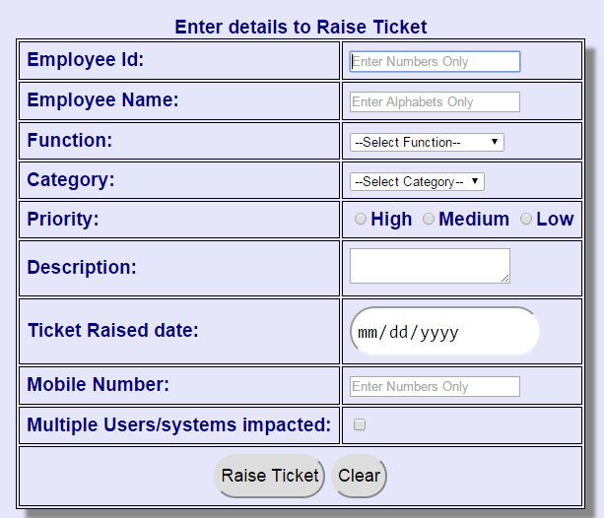

Marks Distribution:

HTML5 and CSS3 functionality
Displaying the form correctly | 4
Validating the form using HTML 5 attributes | 5
CSS Usage | 5
Javascript functionality
Validate the selection of check box | 1
Populating category drop down list based upon function selected | 4
Generating Ticket code | 2
Validating ticket raised date with system date | 2
Displaying data in pop up | 2

Section 3 – Oracle [Marks 25]

Consider the following tables for the below questions.

DROP TABLE Employee_Details CASCADE CONSTRAINTS;
CREATE TABLE Employee_Details(
EmpCode NUMBER(6) PRIMARY KEY,
EmpName VARCHAR2(20) NOT NULL,
ContactNumber NUMBER(10));

INSERT INTO Employee_Details VALUES(824177,'Jack Dickson',9876543256);
INSERT INTO Employee_Details VALUES(824178,'Samantha Mathew',8876593256);
INSERT INTO Employee_Details VALUES(824179,'Emma Clifton',3456781234);
INSERT INTO Employee_Details VALUES(824180,'Harry Davidson',9393943243);
INSERT INTO Employee_Details VALUES(824181,'Alex Parisha',3423543453);
INSERT INTO Employee_Details VALUES(824182,'Simone Clark',9944954543);
INSERT INTO Employee_Details VALUES(824183,'Joe Hardy',7876876867);
INSERT INTO Employee_Details VALUES(824184,'Marie Timberlake',9348484834);

DROP TABLE Ticket_Details CASCADE CONSTRAINTS;
CREATE TABLE Ticket_Details(
TicketCode NUMBER(5) PRIMARY KEY,
EmpCode NUMBER(6) REFERENCES Employee_Details(EmpCode),
Functions VARCHAR2(25) NOT NULL,
Category VARCHAR2(30) NOT NULL,
Description VARCHAR2(100) NOT NULL,
RaisedDate DATE DEFAULT SYSDATE,
Status VARCHAR2(15));

CREATE Sequence ticketSeq START WITH 1000;

INSERT INTO Ticket_Details VALUES(ticketSeq.NEXTVAL,824177,'IT Infrastructure Mgmt','Access Rights','Ticket raised for access rights reqd on trg machine',SYSDATE,'Pending');
INSERT INTO Ticket_Details VALUES(ticketSeq.NEXTVAL,824177,'Admin','Access Control','Ticket raised for access control for Sipcot, Chennai',SYSDATE,'In Progress');
INSERT INTO Ticket_Details VALUES(ticketSeq.NEXTVAL,824179,'IT Infrastructure Mgmt','Asset Allocation','Need allocation for a new Mac machine',SYSDATE,'Pending');
INSERT INTO Ticket_Details VALUES(ticketSeq.NEXTVAL,824179,'Travel and Transport','Bus Transport','Complaint regarding harsh driving of driver of Bus Num MH-15 CQ 5678',SYSDATE,'Solved');
INSERT INTO Ticket_Details VALUES(ticketSeq.NEXTVAL,824179,'Admin','House Keeping','Work place is not kept clean',SYSDATE,'Pending');
INSERT INTO Ticket_Details VALUES(ticketSeq.NEXTVAL,824183,'IT Infrastructure Mgmt','Printer','Ticket raised as paper gets jammed in printer',SYSDATE,'Solved');
INSERT INTO Ticket_Details VALUES(ticketSeq.NEXTVAL,824183,'Travel and Transport','International Travel','Arrange for local transport within San Diego city',SYSDATE,'Pending');
INSERT INTO Ticket_Details VALUES(ticketSeq.NEXTVAL,824184,'IT Infrastructure Mgmt','Asset Allocation','Need allocation for a new machine for new Joinee',SYSDATE,'Pending');
INSERT INTO Ticket_Details VALUES(ticketSeq.NEXTVAL,824184,'Travel and Transport','Bus Travel','Arrange for bus pass for new joinee',SYSDATE,'Pending');
INSERT INTO Ticket_Details VALUES(ticketSeq.NEXTVAL,824184,'Admin','Access Control','Ticket raised for access control for Pune HWD, as new joinee',SYSDATE,'Pending');

Note: Question 1 and 3 are compulsory

- Write a procedure which will accept employee Id and prints ticket details raised by that employee. Do not show resolved tickets raised by the employee.

Note: If the employee Id does not exist raise a user defined exception as "Invalid Employee number:” <Employee Id>. [Marks 12]

Raise report in following format:
Ticket ID | Employee ID | Function | Category | Desc | Status | Raised Date

Write an anonymous block to invoke the procedure

Handling Invalid Employee Number exception | 2
Processing cursor | 5
Handling in /out parameters | 1
Coding conventions | 2
Pl/SQL block to call procedure | 2

- Solve any 2 out of 3. [Marks 5 each]
  - Write a sql query to display details of employees whose tickets are resolved.
  - Write a sql query to make changes in table structure such that ticket status column can take only Pending, In Progress or Solved Values.
  - Write a sql query to display details of employees who have raised tickets in current month (e.g. November 2015) which are not yet resolved.
- Write a sql query to update the status of tickets raised by a particular employee to "In Progress" if current status is 'Pending'. Accept the employee Id from user. [Marks 3]

Section 4 – XML [10 Marks]

- Write XML document based on the data in the customer table given in section 3.
- Write Schema file which will validate the above created XML file.

